3GPP TSG RAN WG1 #125 R1-2604606
Dalian, China, May, 18th - 22nd, 2026

Agenda item: 10.8.3
Source: Sony
Title: Discussion on ISAC Waveform and Frame Structure
Document for: Discussion and Decision

Introduction
A revised version of the study item on 6GR has been approved in RANP#110 [1]. The study on 6GR emphasizes practical user experience, system extensibility, and performance excellence, which are essential to support the anticipated diverse service classes ranging from immersive multimedia and massive IoT to integrated communications and sensing. One of the objectives on sensing aspect is shown below:
- Sensing – Studies to be based on use cases and associated requirements, as defined in [TR38.914]
- PHY functions and procedures for sensing technology (e.g., waveform. reference signals, measurement feedback, etc…) [RAN1, RAN4]
- Evaluate sensing performance and if necessary, extend channel modelling, for the selected use cases [RAN1]
- Aspects of integration with communication services [RAN1]
- higher layer procedures and protocol aspects [RAN2]
- RAN4 aspects of sensing including RF, coexistence, and testability in coordination with other WGs [RAN4]
Note: RAN1 identify detailed requirements, if triggered by TSG RAN

During RAN1#124bis meeting, RAN1 made the following agreements to advance the study[2]:
Agreement:
Study on enhancements on CP-OFDM or other waveforms is not precluded.

6GR communication frame structure is the starting point for 6G ISAC frame structure study, in at least the following aspects.
- Frame/sub-frame/slot/symbol structure
- CP length
- SCS
Enhancements on frame structure/above aspects are not precluded.

Companies are encouraged to provide views on necessity/pros/cons/metrics of LLS and/or SLS and pros/cons/metrics of theoretical waveform characteristics analysis, for evaluation of ISAC waveform and/or integration with communication, to RAN1#125 meeting.

CP-OFDM is used as the benchmark for evaluating the benefits of sensing waveforms.

In this contribution, we elaborate our views on sensing waveform, particularly on potential enhancement based on communication waveform, potential new waveform, frame structure to support 6GR sensing and evaluation aspect.

Discussion

Sensing Waveform
In the recent progress of 6GR study item, CP-OFDM and DFT-s-OFDM have been agreed upon as the baseline waveforms for downlink and uplink communication, respectively. Utilizing these waveforms facilitates the seamless integration of sensing into the communication framework. A primary benefit of waveform reuse is the ability to leverage existing communication reference signals (RS) for sensing purposes. By employing the same physical signals for both communication and sensing, the network can perform sensing tasks without incurring additional radio resource overhead.
Observation 1: The usage of communication waveforms (e.g., CP-OFDM and DFT-S-OFDM) enables the reuse of reference signals for dual-purpose communication and sensing. This approach significantly reduces the spectral and resource overhead required to support sensing operations in 6GR.

CP-OFDM waveform as defined for 6GR has been agreed as the starting point for 6G ISAC waveform study. In our view, any kind of study on potential new 6G ISAC waveform should offer benefit than the CP-OFDM. If CP-OFDM is still superior to the identified new waveform then there is no point on using that in 6GR.
Observation 2: Any 6G ISAC candidate waveform shall provide measurable improvements over the baseline CP-OFDM waveform.
Reusing CP-OFDM that is used for communication to be also used for sensing may poses some issues. RAN1 needs to firstly identify the potential issues or basically identify the motivation on using a new waveform other than CP-OFDM. Here, we are listing some examples as shown below:
- On sensing detection performance: the sensing detection performance can be even better if a dedicated sensing waveform is used.
- On the expected sensing target: CP-OFDM may have an issue if the target object is relatively far from the sensing transmitter / receiver, such that the reflection signal can be exceeding the CP-length.
- On power efficiency/consumption: CP-OFDM is known to have high peak-to-average power ratio (PAPR) issue leading to reducing power amplifier efficiency and high-power consumption.
- On robustness against interference/noise: depending on the scenario, any new waveform may have better robustness over CP-OFDM.
We also need to be aware that any kind of potential new waveform is only intended for sensing. It may not be used for communication purposes. Hence, any potential new waveform may introduce extra overhead on radio resource utilization.
Proposal 1: The study of candidate 6G ISAC waveforms beyond the CP-OFDM baseline should consider:
- Sensing Detection Performance: Including improvements in detection probability, accuracy, and resolution.
- Sensing Coverage: Extending the maximum sensing range and target detectability.
- Power Efficiency: Focused on reducing power consumption and improving hardware efficiency (e.g., via PAPR reduction).
- Spectral Efficiency: Minimizing radio resource overhead compared to existing reference signals.
- Robustness: Enhancing immunity against interference and noise in diverse deployment scenarios.

Once we have identified the general necessity and potential benefit of specifying a new sensing waveform then we can study deeper in the context of sensing modes. In the last meeting, it was agreed to study on the necessity and potential benefits of specifying a waveform for several sensing modes, such as TRP-TRP bistatic sensing, TRP monostatic, and UE monostatic. In our view, specifying a waveform for those sensing modes are still needed, particularly to address the interoperability between sensing nodes. For example, it is obviously needed on TRP-TRP bistatic when the TRP are from different vendor. For the monostatic case, such as UE monostatic, the sensing operation may be controlled/triggered by other nodes (e.g., aNB, SF). Those sensing nodes that is involved, such as controlling/triggering, the sensing monostatic operation, shall be aware on the sensing waveform and its configuration.
Proposal 2: Support the specification of sensing waveforms (if identified and showing performance gains over the CP-OFDM baseline) across all sensing modes, including TRP-TRP bistatic, TRP monostatic, and UE monostatic. This is essential to ensure seamless interoperability and coordination between participating nodes such as the UE, aNB, and Sensing Function (SF).

One another potential area on the study of 6G ISAC waveform is on the operation of multi-static sensing for cooperative sensing. In the cooperative sensing, multiple sensing entities, such as sensing receiver, are deployed. The sensing measurement output from each sensing receiver are jointly used to produce sensing estimates. In practice, there may be a case where there is only one sensing transmitter and/or sensing receiver that is nearby the sensing target (object). The other sensing transmitter/receiver may be far away. Hence, the sensing detection performance involving sensing entities that is relatively far away from the object may have bad sensing detection result. It may be the case that the usage of new waveform other than CP-OFDM may improve the sensing detection result, particularly in the cooperative sensing case. In another example, the usage of CP-OFDM is good in one case but it may not be as expected in the cooperative sensing case.

Proposal 3: Support the study of 6G ISAC waveforms in multi-node cooperative sensing scenarios. (e.g., whether the candidate 6G ISAC waveform can be better than CP-OFDM in cooperative sensing scenarios).

We consider the scope of sensing waveform can be done in two different distinctive options. Option one is to enhance the existing CP-OFDM, in which it may require additional operation before and/or after the FFT operation. In this case, the generated signal/channel is still based on CP-OFDM operation. This enhancement may include modifying the reference signal (e.g., use for communication) and also modifying the data channel. On modifying the data channel to support sensing can be seen as an effot to reduce the radio resource overhead. Option two is to introduce a completely new waveform, other than CP-OFDM, or also known as a dedicated sensing waveform. It can be radar-like sensing, such as Linear Frequency Modulation (LFM) signal, chirp signal, LFM-OFDM, OTFS, etc. In our view, we should prioritize the study on enhancement of CP-OFDM for sensing purpose over the study on introducing a dedicated non CP-OFDM sensing waveform.

Proposal 4: Prioritize the study of CP-OFDM-based enhancements for sensing applications over the development of dedicated non-CP-OFDM sensing waveforms.

As an example, we will elaborate on CP-OFDM sensing waveform by modifying the data channel for sensing. This will enable simultaneous sensing and communication. For monostatic sensing mode with simultaneous communication, [3] demonstrates that different modulation schemes give rise to a trade-off between sensing and communication performance. To quantify sensing performance, a simple scalar metric is determined in [3]; this metric is termed $c_{0}$ in [3] and allows for a direct comparison of sensing performance between modulation schemes.

Furthermore, [3] advocates for a probabilistic shaping of a standard rectangular QAM constellation as it leads to a more favourable operating point than equiprobable QAM, i.e., superior sensing performance for equal communication performance. An alternative to probabilistic shaping, with superior performance is to create a negative correlation among pairs of adjacent subcarriers. This can be accomplished in a number of ways, but a particularly simple one is described next:

1. For the first subcarrier within the pair, choose a symbol from the 32-ary constellation in Figure 1.
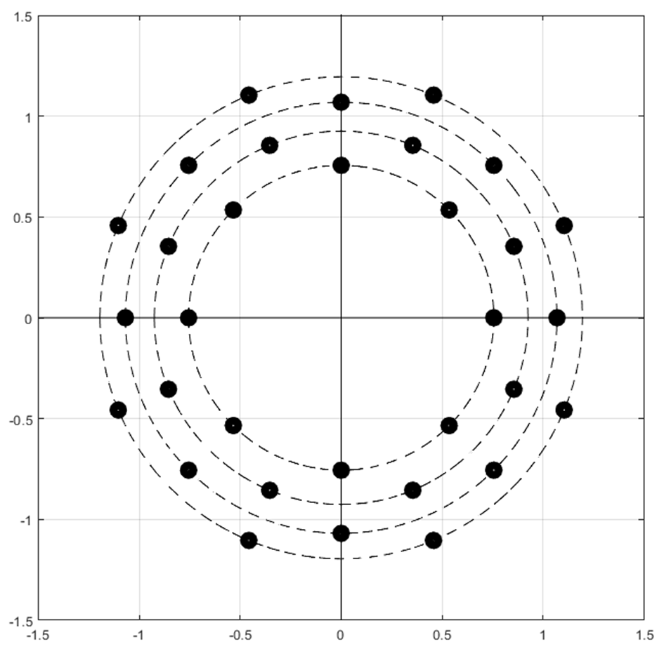
Figure 1: Example constellation for first subcarrier within a pair of subcarriers.

2. If the first symbol is on the $p$:th circle (where the innermost circle corresponds to $p=1$), then choose a symbol from the $\left(5-p\right)$:th circle on the second subcarrier.

Altogether, this maps 8 bits to two subcarriers, and is therefore comparable to 16QAM. It can be verified, using formulas readily available in [2] for computing $c_{0}$, and standard tools for determining the communication performance of a constellation, that this modulation format is (strongly) superior to probabilistic shaping (and standard 16QAM).

Observation 3: Probabilistic shaping is superior to standard rectangular QAM with respect to sensing performance for the same communication performance.
Observation 4: Multi-dimensional constellations perform better than probabilistic shaping of standard QAM.

Proposal 5: Study the feasibility and performance of leveraging communication data symbols (e.g., PDSCH/PUSCH payload) for sensing purposes to maximize sensing opportunities and spectral efficiency in 6GR.

Frame Structure Design for 6G-ISAC
In legacy NR, the time domain resource allocation is configured by SIB1 for cell-level semi-static configuration of uplink (UL) slots, downlink (DL) slots, or flexible slots. Subsequently, the symbols format can be configured in flexible slots as uplink transmission symbols or downlink transmission symbols through RRC layer signalling or physical layer signalling. In 6GR TDD mode, the design of frame structure should consider the compatibility of communication and sensing, especially in the scenario of multi base station (i.e., aNB) cooperation to achieve sensing. Designing and configuring dedicated sensing time slots can be helpful for the implementation of sensing operation. Considering that the sensing slots can be unused when there is no sensing service, this may cause the risk of radio resource underutilization. To maintain spectral efficiency, the framework should allow the base station to dynamically repurpose idle sensing slots for either UL or DL transmission.

Effective sensing operation requires careful interference management between adjacent cells. For communication purpose, adjacent cells typically maintain synchronized DL/UL ratios to minimize cross-link interference. Conversely, the sensing frame structure for adjacent cells should be configured in pairs. As illustrated in Figure 2, in Bi-static mode, base station A transmits sensing signals, and base station B is the target BS to receive the sensing signals. Therefore, in the frame structure design of adjacent cells, the uplink and downlink of sensing time slots need to be configured accordingly, in this example, the sensing slot is introduced and highlighted in yellow. For base station A, the sensing signal is transmitted with the configuration of the downlink sensing slot. For base station B, the sensing signal is received in the uplink sensing slot. Besides the sensing signal will be transmitted or received by the adjacent base station, it can also be received by the UE once 6G UE has the sensing transmit and receive capability. Thus, this configuration can also be provided and configured to UE.

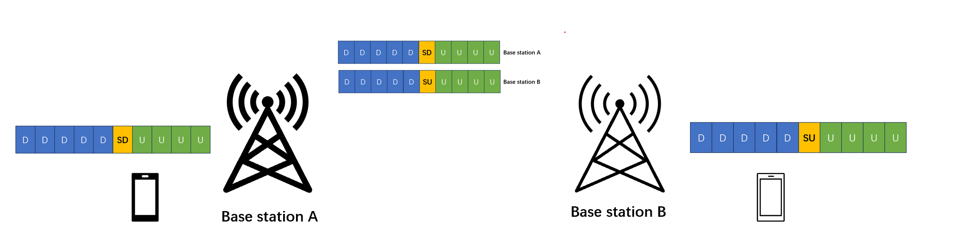
Figure 2: Illustration of flexible sensing slot allocation

Proposal 6: Support dedicated sensing slots for 6GR TDD mode that can that allow for fallback to communication services (e.g., when sensing resources are not in use).

Evaluation for 6G Sensing Waveform
Once candidate 6G sensing waveform(s) are identified, they shall be evaluated to justify any performance gains over the baseline CP-OFDM waveform. CP-OFDM waveform serves as the mandatory benchmark for assessing new sensing waveform proposals. This benchmarking shall focus on the critical trade-offs between implementation complexity, sensing detection performance, and power efficiency (specifically through Peak-to-Average Power Ratio (PAPR) analysis).
Proposal 7: The benchmark of the potential new 6G sensing waveform(s) versus CP-OFDM waveform shall consider the trade-off between complexity, detection performance, and power efficiency (e.g., via PAPR metrics).

To facilitate the sensing waveform evaluation, a standardized simulation methodology is required. During the RAN1#124bis meeting, several approaches were discussed, including Link-Level Simulation (LLS), System-Level Simulation (SLS), Simplified SLS (S-SLS), and theoretical/numerical analysis.
While LLS is a mature tool for evaluating communication waveforms, specific ISAC LLS channel models were not developed during the Rel-19 ISAC Channel Modeling (CM) Study Item (SI). Consequently, adopting LLS would require significant additional effort from RAN1 to define standardized ISAC link-level parameters. A more efficient alternative is the use of S-SLS. Given that ISAC SLS modeling was finalized during the Rel-19 ISAC CM SI, S-SLS offers a balanced and ready-to-use framework for 6G sensing waveform evaluation.
Proposal 8: Support the adoption of Simplified System-Level Simulation (S-SLS) as the primary methodology for evaluating candidate 6G sensing waveforms.

Conclusion
In this contribution, we have made the following observations and proposals:
Observation 1: The usage of communication waveforms (e.g., CP-OFDM and DFT-S-OFDM) enables the reuse of reference signals for dual-purpose communication and sensing. This approach significantly reduces the spectral and resource overhead required to support sensing operations in 6GR.
Observation 2: Any 6G ISAC candidate waveform shall provide measurable improvements over the baseline CP-OFDM waveform.
Observation 3: Probabilistic shaping is superior to standard rectangular QAM with respect to sensing performance for the same communication performance.
Observation 4: Multi-dimensional constellations perform better than probabilistic shaping of standard QAM.

Proposal 1: The study of candidate 6G ISAC waveforms beyond the CP-OFDM baseline should consider:
- Sensing Detection Performance: Including improvements in detection probability, accuracy, and resolution.
- Sensing Coverage: Extending the maximum sensing range and target detectability.
- Power Efficiency: Focused on reducing power consumption and improving hardware efficiency (e.g., via PAPR reduction).
- Spectral Efficiency: Minimizing radio resource overhead compared to existing reference signals.
- Robustness: Enhancing immunity against interference and noise in diverse deployment scenarios.
Proposal 2: Support the specification of sensing waveforms (if identified and showing performance gains over the CP-OFDM baseline) across all sensing modes, including TRP-TRP bistatic, TRP monostatic, and UE monostatic. This is essential to ensure seamless interoperability and coordination between participating nodes such as the UE, aNB, and Sensing Function (SF).
Proposal 3: Support the study of 6G ISAC waveforms in multi-node cooperative sensing scenarios. (e.g., whether the candidate 6G ISAC waveform can be better than CP-OFDM in cooperative sensing scenarios).
Proposal 4: Prioritize the study of CP-OFDM-based enhancements for sensing applications over the development of dedicated non-CP-OFDM sensing waveforms.
Proposal 5: Study the feasibility and performance of leveraging communication data symbols (e.g., PDSCH/PUSCH payload) for sensing purposes to maximize sensing opportunities and spectral efficiency in 6GR.
Proposal 6: Support dedicated sensing slots for 6GR TDD mode that can that allow for fallback to communication services (e.g., when sensing resources are not in use).
Proposal 7: The benchmark of the potential new 6G sensing waveform(s) versus CP-OFDM waveform shall consider the trade-off between complexity, detection performance, and power efficiency (e.g., via PAPR metrics).
Proposal 8: Support the adoption of Simplified System-Level Simulation (S-SLS) as the primary methodology for evaluating candidate 6G sensing waveforms.

References
- RP-253876, “Revised SID: Study on 6G Radio”, NTT DOCOMO, CMCC, AT&T, Vodafone, Baltimore, US, December 8-11, 2025.
- Chairman’s notes, RAN1#124bis meeting, St. Julian – Malta, April 2026.
- Z. Du, F. Liu, Y. Xiong, T.X. Han, Y.C. Eldar, and S. Jin, "Reshaping the ISAC tradeoff under OFDM signaling: A probabilistic constellation shaping approach”. IEEE Transactions on Signal Processing, pp. 4782-4797, vol. 72, Sept., 2024.

